CATERING /
COCKTAIL PARTY

The following items are perfect bites for your cocktail party.
Cheese Boards are on the last page.

Minimum order is 40 of any one item.
Minimum order is $600.
Sausalito Tax 9.25% and Service 20% is added to the final bill.
Pickup or delivery included in Sausalito.

COCKTAIL BITES FROM LAND

$5 per piece, minimum 40 of any one item

Special / 375 pieces for $1000
(5 different items from this page, with 75 pieces of each)

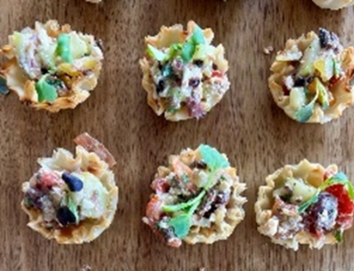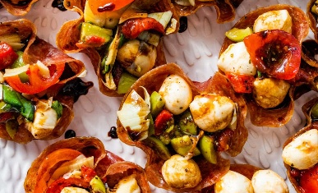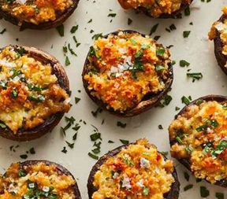

CHOOSE: VEGAN, VEGETARIAN, CHICKEN, PORK or BEEF
CHOOSE: PHYLLO CUP, ENDIVE LEAF

INDIAN RAISONS, YELLOW CURRY, VEGGIES
MOROCCAN 1 CRISPY CHICKPEAS, CHERMOULA, APRICOT, ALMONDS, LEMON, PARSLEY
PESTO CAPRESE MOZZARELLA, TOMATO, BASIL-PESTO
SHAWARMA LEMON, ROASTED PEPPER, TZATZIKI, PARSLEY
BBQ BBQ SAUCE, ROASTED CORN, CHIVE
MOZAMBIQUE PIRI-PIRI, CITRUS, GINGER, SCALLION, GARLIC, CILANTRO, KEWPIE
MEDITERRANEAN KALAMATA TAPENADE, SUN-DRIED TOMATO, LEMON YOGURT, FETA, OREGANO
VIETNAMESE CABBAGE, MINT, BASIL, CILANTRO, FISH SAUCE LIME, CRISPY SHALLOTS, CRUSHED PEANUTS
KOREAN GOCHUJANG, RICE VINEGAR, SESAME OIL, SCALLIONS, KEWPIE
CHIPOTLE ROASTED CORN, ROASTED ONIONS & PEPPERS, CHIPOTLE MAYO, CILANTRO-LIME CREMA
GREEK CUCUMBER, FETA, TOMATO, OLIVE, VINAIGRETTE
PANZANELLA STONE FRUIT, BURRATA, BASIL, HONEY-CHAMPAGNE VINAIGRETTE
STREET CORN COTIJA CHEESE, LIME, CILANTRO, SMOKED CHILI AIOLI
MEDITERRANEAN HUMMUS, POMEGRANATE, EVOO, SUMAC
MOROCCAN 2 CARROT, ORANGE, DATES, PISTACHIO, CUMIN-PAPRIKA
THAI GREEN MANGO, THAI BASIL, PEANUTS, CHILI-LIME
PEAR & BLUE CHEESE CANDIED WALNUT, CHIVES, HONEY-WHITE BALSAMIC
JACK’S GUACAMOLE AVOCADO, RED ONION, GARLIC, CILANTRO, LIME, SEA SALT

………………………..

STUFFED DATE WRAPPED WITH PROSCIUTTO & STUFFED WITH POINT REYES BLUE CHEESE
STUFFED MUSHROOM BOURSIN CHEESE, PANKO
STUFFED MUSHROOM LINGUICA SAUSAGE, CHEESES, AUTUMN HERBS
STUFFED MUSHROOM HOT ITALIAN SAUSAGE, SWEET ONION, JACK CHEESE
STUFFED JALAPENO STREET CORN, CHORIZO, MEXICAN CHEESES, RED ONION, TAJIN
STUFFED JALAPENO STREET CORN, ONIONS & PEPPERS, MEXICAN CHEESES, CREAM CHEESE, TAJIN

………………………..

PROSCIUTTO CUP CHICKEN PARMESAN, TOMATO SAUCE, MOZZARELLA
SALAMI CUP MOZZARELLA, TOMATO, RST PEPPERS, OLIVES, ARTICHOKE
SALAMI CUP SUNDRIED TOMATOES, FETA, OLIVES, CARAMELIZED ONION, HONEY, THYME

COCKTAIL BITES FROM THE SEA

$7 per piece, minimum 40 of any one item

Special / 375 pieces for $1500
(5 different items from this page, with 75 pieces of each)

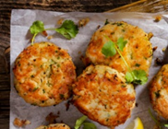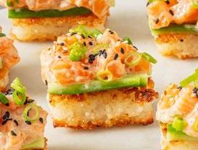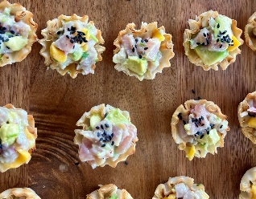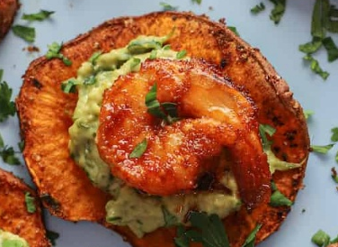

CRAB CAKE CITRUS AIOLI
SALMON CAKE CITRUS AIOLI
SHRIMP CAKE CITRUS AIOLI
SCALLOP CAKE CITRUS AIOLI

PHYLLO CUP AHI TUNA CEVICHE CITRUS, CILANTRO, CHILI, MANGO
PHYLLO CUP SALMON TARTARE AVOCADO, MISO TAMARI SAUCE
PHYLLO CUP PERUVIAN SCALLOP CHOCLO GRANO CORN, CITRUS, AJI AMARILLO

CROSTINI SMOKED SALMON DILL CREAM CHEESE, SALMON ROE

CRISPY RICE KING SALMON KEWPIE, SRIRACHA, LIME, SESAME, SOY SAUCE

CROQUETTE LOBSTER ROMESCO, GARLIC AIOLI

CRISPY POTATO SMOKED SALMON ROE CRÈME FRAICHE
CRISPY PARMESAN SMOKED SALMON DIP

CHIP POTATO KALUGA CAVIAR CRÈME FRAICHE
CHIP SWEET POTATO CAJUN SHRIMP AVOCADO

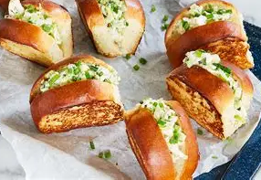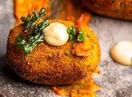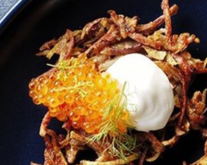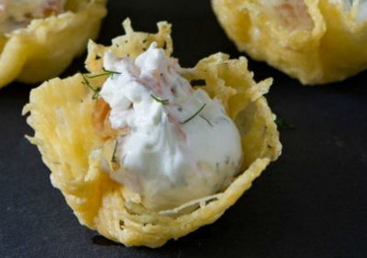

CHEESE & CHARCUTERIE DISPLAYS

$300. per board. (charcuterie or no meat – your choice)

Cheese & Charcuterie Boards
Lavish displays featuring local cheeses, salumi, dried fruits, fresh fruits, nuts, jams, crackers and more.

