CATERING /
COCKTAIL PARTY

The following items are perfect bites for your cocktail party.
Cheese Boards are on the last page.

Minimum order is 30 of any one item.
Minimum order is $800.
Sausalito Tax 9.25% and Service 20% is added to the final bill.
Pickup or delivery included in Sausalito.

COCKTAIL BITES / FROM THE SEA

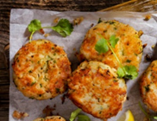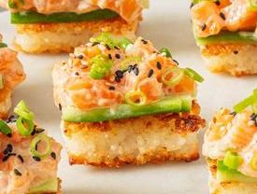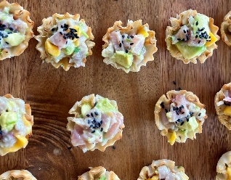

MINI CRAB CAKE CITRUS AIOLI $10
MINI SALMON CAKE CITRUS AIOLI $10
MINI SHRIMP CAKE CITRUS AIOLI $10

MINI SCALLOP BACON WRAPPED $10
MINI LOBSTER ROLL LEMON CAVIAR $14

PHYLLO CUP AHI TUNA CEVICHE CITRUS, CILANTRO, CHILI, MANGO $8
PHYLLO CUP SALMON TARTARE AVOCADO, MISO TAMARI SAUCE $8
PHYLLO CUP PERUVIAN SCALLOP CHOCLO GRANO CORN, CITRUS, AJI AMARILLO $8

CROSTINI SMOKED SALMON DILL CREAM CHEESE, SALMON ROE $9

CRISPY RICE SALMON KEWPIE, SRIRACHA, LIME, SESAME, SOY SAUCE $8

CROQUETTE LOBSTER POTATO, GOAT CHEESE, PANKO, TARRAGON, CHIVES $14

CRISPY POTATO SMOKED SALMON ROE CRÈME FRAICHE $10
CRISPY PARMESAN SMOKED SALMON DIP $8

CHIP POTATO KALUGA CAVIAR CRÈME FRAICHE $14
CHIP SWEET POTATO CAJUN SHRIMP AVOCADO $8

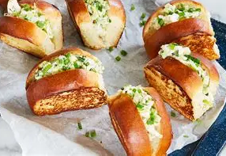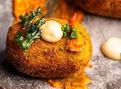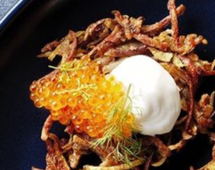

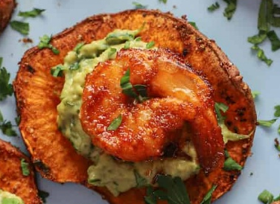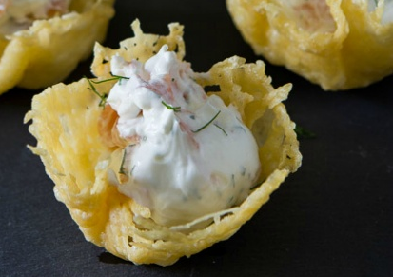

COCKTAIL BITES / FRESH & SEASONAL

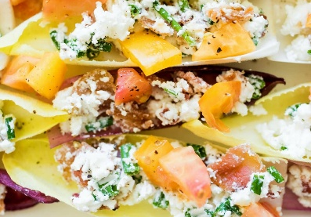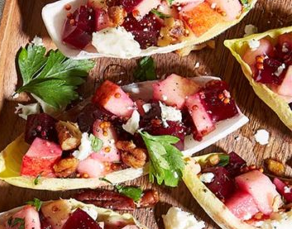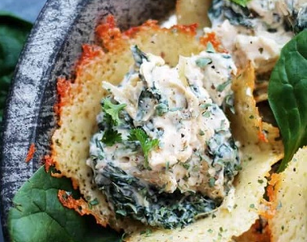

PHYLLO CUP GREEK CUCUMBER, FETA, TOMATO, OLIVE $6
PHYLLO CUP PANZANELLA CHERRIES, BURRATA, BASIL, HONEY-CHAMPAGNE $6
PHYLLO CUP STREET CORN COTIJA, LIME, CILANTRO, SMOKED CHILI AIOLI $6
PHYLLO CUP MEDITERRANEAN HUMMUS, POMEGRANATE, EVOO, SUMAC $6
PHYLLO CUP MOROCCAN CARROT, ORANGE, DATES, PISTACHIO, CUMIN-PAPRIKA $6
PHYLLO CUP THAI GREEN MANGO, THAI BASIL, PEANUTS, CHILI-LIME $6
PHYLLO CUP PEAR & BLUE CHEESE CANDIED WALNUT, CHIVES, HONEY-WHITE BALSAMIC $6

ENDIVE LEAF BACON, CHIVES, HEIRLOOM TOMATO, GOAT CHEESE $7
ENDIVE LEAF GRANNY APPLE, RED BEET, BLUE CHEESE $6
ENDIVE LEAF JACK’S GUACAMOLE RED ONION, GARLIC, CIANTRO, LIME, SEA SALT $7

CRISPY PARMESAN SPINACH & ARTICHOKE HEART DIP $7
CRISPY PARMESAN CAESAR SALAD CROUTON, ROMAINE, YOGURT PEPPER DRESSING $6

JALAPENO STREET CORN CREAM CHEESE, MEXICAN CHEESES, RED ONION, TAJIN $6

SKEWER MELON, MOZZARELLA, BASIL, PROSCIUTTO, LEMON MINT PESTO $8

FIG* CARAMELIZED BRIE $8

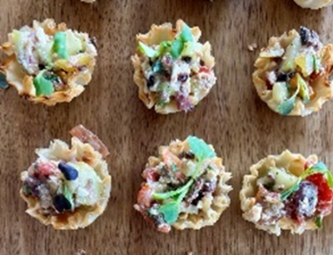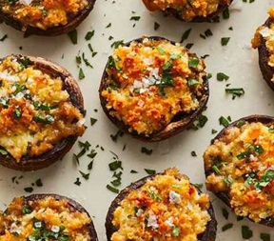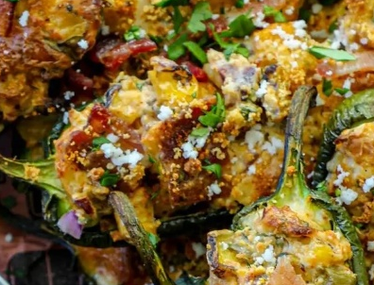

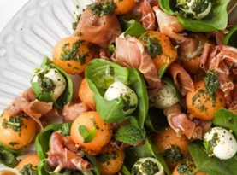

COCKTAIL BITES / SAVORY

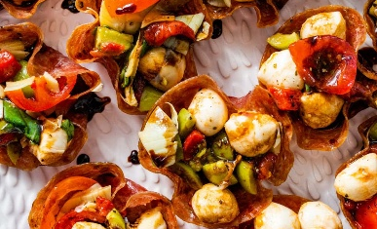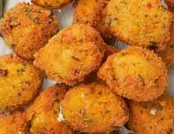

PHYLLO CUPS YELLOW CURRY CHICKEN, RAISONS $6
PHYLLO CUPS MOROCCAN CHICKEN, CHERMOULA, APRICOT, ALMONDS $6
PHYLLO CUPS THAI CHICKEN, CABBAGE, VEGGIES, PEANUT-LIME, CILANTRO $6
PHYLLO CUPS PESTO CAPRESE CHICKEN, MOZZARELLA, TOMATO, BASIL-PESTO $6
PHYLLO CUPS SHAWARMA CHICKEN, LEMON, RST PEPPER, TZATZIKI, PARSLEY $6
PHYLLO CUPS BBQ & PICKLED ONION CHICKEN, RST CORN, CHIVE

DATES PROSCIUTTO & PT REYES BLUE CHEESE $6

MUSHROOM BOURSIN CHEESE, PANKO $6
MUSHROOM LINGUICA SAUSAGE, CHEESES, AUTUMN HERBS $7
MUSHROOM HOT ITALIAN SAUSAGE, SWEET ONION, JACK CHEESE $7

JALAPENO STREET CORN CHORIZO, MEXICAN CHEESES, RED ONION, TAJIN $7

PROSCIUTTO CUP CHICKEN PARMESAN, TOMATO SAUCE, MOZZARELLA $7
SALAMI CUP MOZZARELLA, TOMATO, RST PEPPERS, OLIVES, ARTICHOKE $7
SALAMI CUP SUNDRIED TOMATOES, FETA, OLIVES, CARAMELIZED ONION, HONEY, THYME $7

MINI EMPANADAS SPANISH BEEF, ONION, OLIVES, RAISONS, CUMIN, PAPRIKA $7
MINI EMPANADAS POPEYE’S SPINACH, ONION & CHEESE $7

CRISPY POTATO CHIPOTLE CHICKEN, CILANTRO LIME CREMA $6

CRISPY OLIVE PT REYES BLUE CHEESE $4

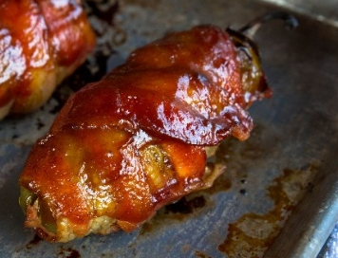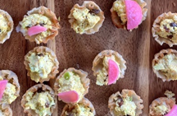

CAVIAR / CAVIAR COMPANY SAN FRANCISCO

KALUGA HYBRID CAVIAR 1 OZ - $85 KILO (35 OZ) - 1850
IMPERIAL GOLDEN OSETRA CAVIAR 1 OZ - $125 KILO (35 OZ) - 2400

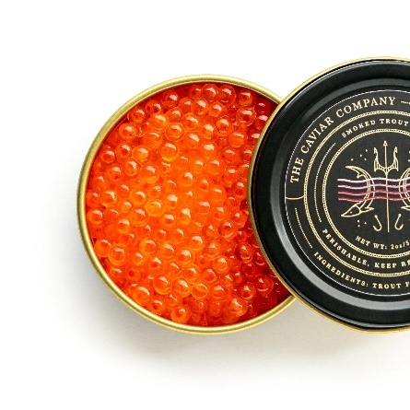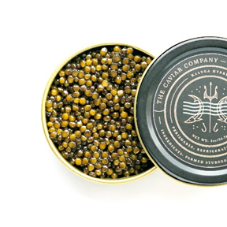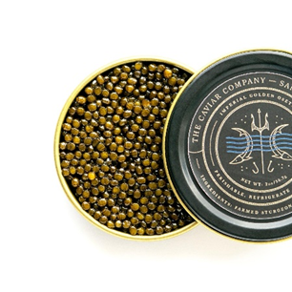

CHARCUTERIE DISPLAYS

Cheese & Charcuterie Boards
Lavish displays featuring local cheeses, salumi, dried fruits, fresh fruits, nuts, jams, crackers and more.
$300. per board. (1 board = 25 guests)

