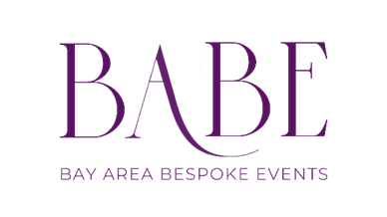
BABE AFTER HOURS
A stylish monthly cocktail hour that boosts team morale and turns your office into
the place everyone wants to be.

BABE After Hours is your recurring corporate cocktail hour — a chic, end-of-day social designed to bring teams together with elevated bites, optional bespoke cocktails, and an effortlessly stylish vibe.

Perfect for companies looking to strengthen culture, celebrate milestones, welcome new hires, or simply make
office life feel exciting again.

You can add live music, photo booth, flowers and bespoke performances to your event.

What’s Included

- Monthly in-office cocktail hour (weekday or weeknight)
- Five (5) curated passed bites (serves as light dinner)
- Signature BABE Classic grazing board
- Setup, service, and full breakdown
- Eco-friendly disposables or corporate glassware
- Menu planning + monthly rotation
- Onsite hospitality

Menus revolve around seasonal ingredients - picking a cuisine, region, century, holiday, theme — created
specifically for your event.

Pricing

Per-Event: $1,200–$2,000
Recurring Discounts: Available for 3-, 6-, and 12-month commitments
Pricing varies by menu selection, staff needs, and add-ons.

Perfect For
- Monthly morale builders
- Employee appreciation
- Client receptions
- Team celebrations
- Product launches
- Internal networking
- Recruiting + new hire welcome events

BABE After Hours turns “staying late” into something people actually look forward to.

Menu Structure

Each After Hours event includes:

Passed Bites (Five per event)
Seasonal rotation inspired.

Grazing Board
Seasonal rotation inspired.

Optional Signature Cocktails
Bespoke monthly cocktail recipes.

Monthly Themes (Optional)
Sushi Night • Taco Bar Social • Mediterranean Mezze • Spritz Season • Fall Harvest Hour

Optional Enhancements

- Live music, performance, entertainment

- Rentals (Linens, plates, silverware, glassware…)
- Tablescaping + buffet styling (+$250–$850)

- Additional passed appetizer (+$6–$12 per guest)
- Premium protein selections (+MP)

- On-site Wine sommelier (+$300, 3-hour service window)
- Bartender (+300, 3-hour service window)
- Additional staff (+$300 per staff member, 3-hour service window)

The After Hours Experience
Stylish. Social. Effortless.

BABE After Hours brings warm hospitality and elevated food directly into your workplace — transforming ordinary office hours into something memorable and energizing.

Ready to Book BABE After Hours?
Let’s make something beautiful. / contact me at sherwood@bespokebayarea.com / 973 567 8569

